**References:**

Coursera – Andrew NG ML/DL courses

<https://datascience-enthusiast.com/DL/Building_a_Recurrent_Neural_Network-Step_by_Step_v1.html>

<https://d2l.ai/chapter_recurrent-modern/gru.html>

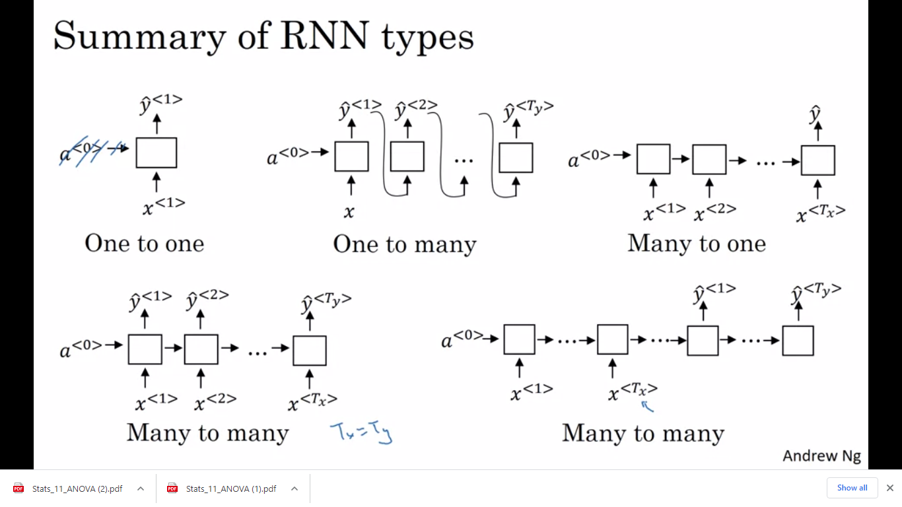

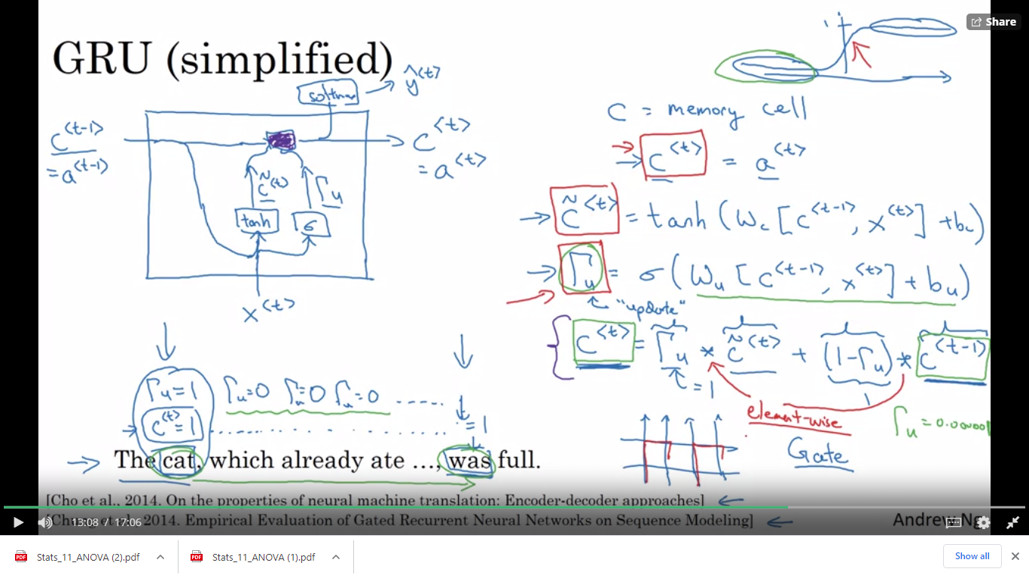

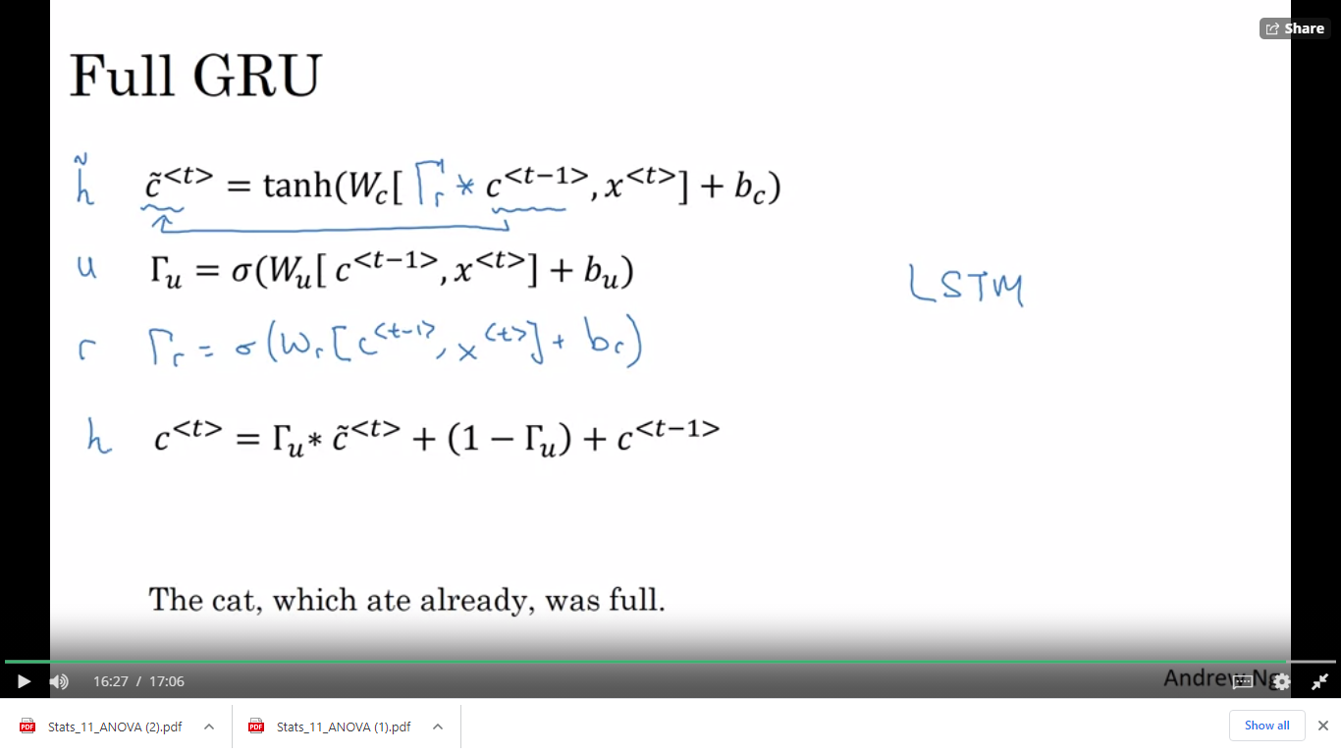

*c*<*t*>=Γ*u*​∗*c*~<*t*>+(1−Γ*u*​)∗*c*<*t*−1>

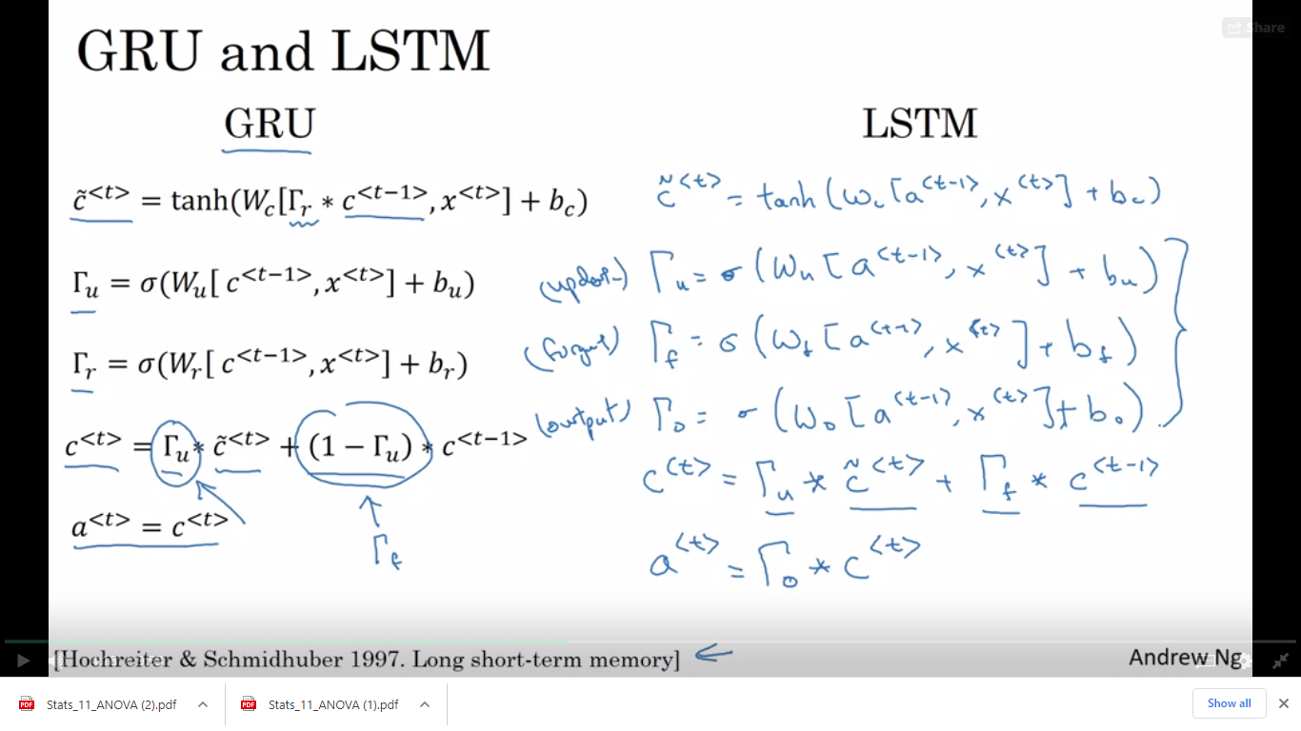

# *a*<*t*>=Γ*o*​∗tanh(*c*<*t*>)

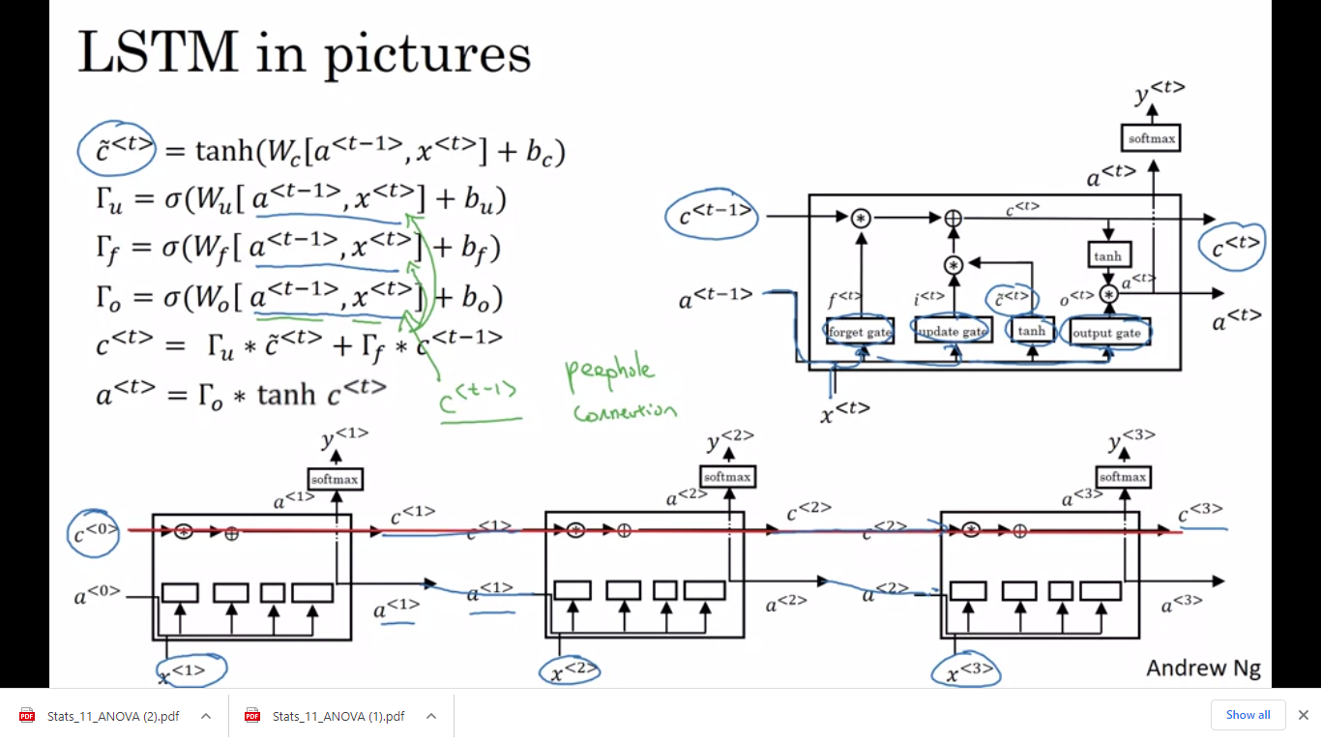

# *a*<*t*>=Γ*o*​∗tanh(*c*<*t*>)